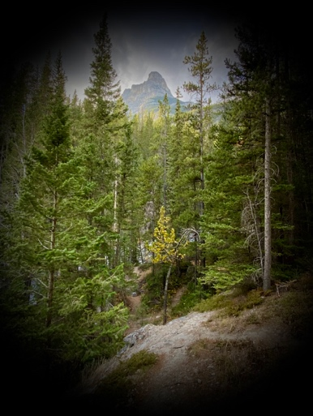
“Our Identity in Christ” Workshop
June 6 & 7, 2026 – 10:00-5:00 (6th) and 2:00-6:00 (7th).
Cost $130
Our identity in Christ starts with how God sees us, not how we see ourselves or what we think about ourselves. As Paul puts it in 2 Corinthians 5, who we are as a “new creation” actually begins in God’s heart and mind! Until we start to see how God sees us and we begin to accept that view, our self-perception is limited and never fully reflects the life God has for us (John 10:10, “life to the full”). That’s what this workshop is all about. It’s not meant to give us all the answers, but to guide us on a journey to understand, learn and grow in our identity in Christ.
The way we treat ourselves, how we interact with other Christians, non-Christians, the church and so on, all stems from our beliefs about God and ourselves. What we believe about how God sees us is crucial to our daily thoughts, attitudes and actions. It’s when I begin to understand how God sees me and accept that as a true and accurate view of myself that my life starts to grow in openness and ability to interact with others the way Jesus did. This is where freedom comes. This is where abundant life begins. But it’s a process. It’s a pathway that will take us the rest of our lives. This workshop is designed to set us on that pathway or encourage us along it to a greater understanding and a deeper connection with God.
Some of the topics we will look at include
- Where does my sense of identity come from?
- How am I created to know my identity?
- The difference between how God sees me and how I see myself
- Do I have an accurate perception of myself and God?
- How do I let this make a difference in my day-to-day life?
- And others…
To register or get additional information you can visit the website connectionswithGod.ca or email Orban directly.

